|  | **Mahatma Education Society’s**  **Pillai College of Engineering**  **Accredited A+ by NAAC**  **Dr. K. M. Vasudevan Pillai Campus,**  **Plot No. 10, Sector-16, New Panvel - 410206** |
| --- | --- |

A Report on

**Digital Voting Machine using MC PIC 18f2550**

for

**Mini Project 2a (REV- 2019 ‘C’ Scheme) of Third Year, (TE Sem-V)**

in

**Electronics & Telecommunication Engineering**

by

B01 DIVYA MOKAL

B04 ADITYA NAIR

B05 NAMITHKUMAR NAIR

B17 RINKU PATIL

Under the guidance of

**Prof. Harsha Ghadge**



**UNIVERSITY OF MUMBAI**

**AY 2021-2022**

**CERTIFICATE**

This is to certify that the project entitled **Digital Voting Machine using MC PIC18f2550** is a bonafide work of

B01 DIVYA MOKAL

B04 ADITYA NAIR

B05 NAMITHKUMAR NAIR

B17 RINKU PATIL

submitted to the University of Mumbai in partial fulfillment of the requirement for the award of **Mini Project 2a (REV- 2019 ‘C’ Scheme) of Third Year, (TE Sem-V)** in **Electronics & Telecommunication Engineering** as laid down by **University of Mumbai** during academic year **2021-22**

(_____________________) (_____________________)

**Internal Examiner External Examiner**

|  |  |  |
| --- | --- | --- |
| **Name of Guide** | **Dr. Avinash Vaidya** | **Dr. Sandeep Joshi** |
| **Guide** | **Head of Department** | **Principal** |

**INDEX**

| **Sr.No** | **Topic Name** | **Page no** |
| --- | --- | --- |
| **1** | **Abstract** | **4** |
| **2** | **Introduction** | **5** |
| **3** | **Components Used** | **6** |
| **4** | **Circuit Diagram** | **10** |
| **5** | **Program Code** | **11** |
| **6** | **Result(Output)** | **19** |
| **7** | **Advantages & Disadvantages** | **20** |
| **8** | **Conclusion** | **21** |
| **9** | **Reference** | **22** |

**ABSTRACT**

Voting is most pivotal process of democratic society through which people determine its government. Governments around the world are increasingly considering the replacement of traditional paper-based voting schemes with digital voting systems. In Project we describe the design, construction and operation of a digital voting machine using PIC18f2550 (microcontroller). It is an effective tool for voting, it is a combination of mechanical electromechanical and electronic equipment and is used to display election results and to maintain and produce any audit trial information which can be used in system.

**Introduction**

PIC18F2550 microcontroller is an 8-bit microcontroller designed by MICROCHIP. It is one of the cheapest microcontrollers of PIC18FXXXX series. It is popular due to its performance, cheapness and multiple features. PIC18F2250 microcontroller can interface directly with the other PC. It has multiple helping material on the internet due to its popularity and that is one the reason most of the developers and engineers use it. The microcontroller can keep the peripheral still active when the CPU core is on stand by and usage of internal oscillator also led the controller to save up to 90% power saving.

Digital Voting Machine (DVM) retains all the characteristics of voting by ballot papers, while being fast and absolutely reliable the EVM saves considerable time, money and manpower. It also helps to maintain total voting secrecy without the use of ballot papers. The DVM is 100% temper proof and at the end of the polling, just press a button and you get the result. Electronic voting machine has become a very effective tool since it was introduced. Because of its precision, reliability and secrecy while voting it has become very popular. Since it doesn’t require any manpower, it is more economical and also avoids any kind of malpractice and invalid votes. It is also convenient to the voter as he/she has to just press one key whichever belongs to the candidate.

**Components Used:**

LED green

LED brig

Crystal Oscillator

Capacitor

Resistor

LCD display

Pic 18f2550

Button

**Components Description:**

**LED** - A light-emitting diode is a semiconductor light source that emits light when current flows through it. Voting machine contains two LED’s. When LED1 remains on, others buttons can perform. When LED2 remains on, all buttons are disabled.

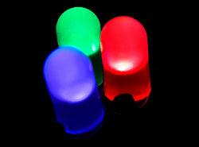

**LCD Display** – This is 2*16line LCD Display.

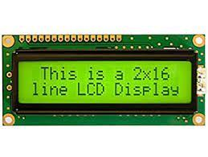

**PIC 18F2550 MICROCONTROLLER**

PIC18F2550 microcontroller is an 8-bit microcontroller designed by MICROCHIP. It is one of the cheapest microcontrollers of PIC18FXXXX series. It is popular due to its performance, cheapness and multiple features. PIC18F2250 microcontroller can interface directly with the other PC. It has multiple helping material on the internet due to its popularity and that is one the reason most of the developers and engineers use it. The microcontroller can keep the peripheral still active when the CPU core is on stand by and usage of internal oscillator also lead the controller to save up to 90% power saving.

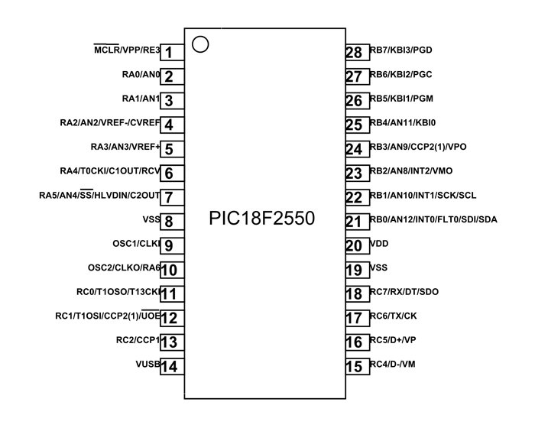 **PIC18F2550 Pin Configuration:-**

**PIC18F2550 Features and Peripherals:-**

In this section, we will see all the features and details of built-in features available.

**DIGITAL OUTPUT PINS**

The microcontroller has four GPIO ports (A, B, C and E). Instead of E, all ports provide the output function. The output pin attaches to the port A and B gives the TTL logic but the port C output comes in ST logic. The output pins on PIC18F2250 are :

RA0 – GPIO2 , RA1 – GPIO3 , RA2 – GPIO4

RA3 – GPIO5 , RA4 – GPIO6 , RA5 – GPIO7 , RA6 – GPIO10

RB0 – GPIO21 , RB1 – GPIO22 , RB2 – GPIO23 , RB3 – GPIO24

RB4 – GPIO25 , RB5 – GPIO26 , RB6 – GPIO27 , RB7 – GPIO28

RC0 – GPIO11 , RC1 – GPIO12 , RC2 – GPIO13 , RC6 – GPIO17

RC7 – GPIO18

**DIGITAL INPUT PINS**

In PIC18F2550 the number of input pins is more than any other pins. Every port comes with input capability. Input pins on port A & B all input pins can be operated with TTL input but in port C (RC4 and RC5) can only operate with TTL input other pins on port C and E required ST logic to operate otherwise it could cause a problem for the microcontroller program to understand and operate properly. List of all input pins are:

RA0 – GPIO2

RA1 – GPIO3

RA2 – GPIO4

RA3 – GPIO5

RA4 – GPIO6

RA5 – GPIO7

RA6 – GPIO10

RB0 – GPIO21

RB1 – GPIO22

RB2 – GPIO23

RB3 – GPIO24

RB4 – GPIO25

RB5 – GPIO26

RB6 – GPIO27

RB7 – GPIO28

RC0 – GPIO11

RC1 – GPIO12

RC2 – GPIO13

RC4 – GPIO14

RC5 – GPIO15

RC6 – GPIO16

RC7 – GPIO17

**Push Button** –

The push button switch is usually used to turn on and off the control circuit, and it is a kind of control switch appliance that is widely used It is used in electrick automatic control circuits to manually send control signals to control contactors, relays, electromagnetic starters, etc Its characteristic is that it is installed in the machine and instrument in the process of work, most of the time is in the initial free state position, and only when needed, it is converted to the second state (position) under the action of external force. Once the external force is removed, due to With the action of the spring, the switch returns to the initial position

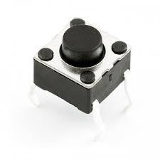

**Crystal Oscillator-** A crystal oscillator is an electronic oscillator circuit that uses the mechanical resonance of a vibrating crystal of piezoelectric material to create an electrical signal with a constant frequency.

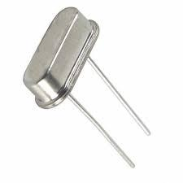

**CIRCUIT DIAGRAM:-**

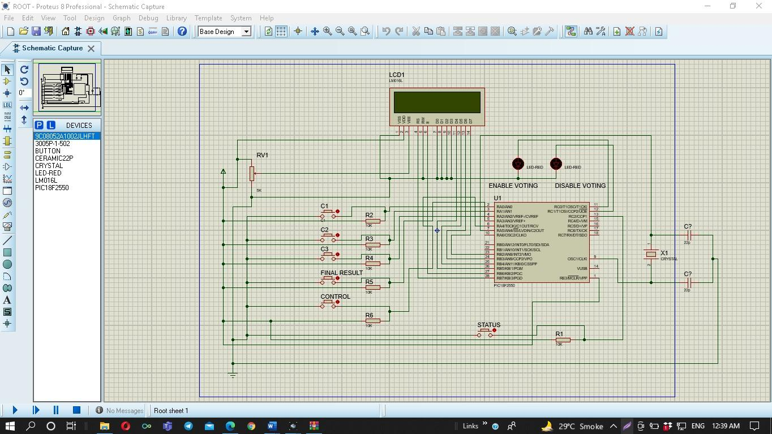

**WORKING:-**

For simply Voting Machine system we have used 3 Push Button which are named as Can 1, Can 2, Can3, the word can represents candidates .however one person can only use one button at a time .

A Control Button is used to allocate permission for voting. When the control button is pressed at the time only one person can use one button from all Can 1,2,3 buttons. After pressing Can 1,2,3 button record will store automatically for another person to vote you need to again activate the control button.

Instead of these one more button is used for viewing status which is authorize only for presiding officer not for voter by which PO can view the status of button which were pressed.

At last we have used final button which will display the result on LCD Display. On display you can simply see who is the winner and then all the data will be reset Automatically.

**PROGRAM CODE:**

sbit LCD_RS at RB7_bit;

sbit LCD_EN at RB6_bit;

sbit LCD_D4 at RB5_bit;

sbit LCD_D5 at RB4_bit;

sbit LCD_D6 at RB3_bit;

sbit LCD_D7 at RB2_bit;

sbit LCD_RS_Direction at TRISB7_bit;

sbit LCD_EN_Direction at TRISB6_bit;

sbit LCD_D4_Direction at TRISB5_bit;

sbit LCD_D5_Direction at TRISB4_bit;

sbit LCD_D6_Direction at TRISB3_bit;

sbit LCD_D7_Direction at TRISB2_bit;

// End LCD module connections

short dat_can1=0,dat_can2=0,dat_can3=0,con=4;

char txt[]=" ";

char txt1[]="htp://pic18fmicrocontroller.blogspot.com";

char txt2[]=" Digital Voting Machine";

int i=0,j=0,chk=10;

char c1i='0',c1j='0',c1k='0';

char c2i,c2j,c2k;

char c3i,c3j,c3k;

int can_1adrs =15; // Keeping memory address for Candidate 1

int can_2adrs =19; // Keeping memory address for Candidate 2

int can_3adrs = 29; // Keeping memory address for Candidate 3

int chkk = 33,aq=0,b=0,aa=0,bb=0,cc=0;

char thirdchar(short dk){ ////find third Char of Short Data

aq=dk/100;

aa=aq*100;

aa=dk-aa;

if(aq==0)

{ aa=dk;

return '0'; }

if(aq==1) return '1';

if(aq==2) return '2';

if(aq==3) return '3';

if(aq==4) return '4';

if(aq==5) return '5';

if(aq==6) return '6';

if(aq==7) return '7';

if(aq==8) return '8';

if(aq==9) return '9';

}

char secondchar(short dk){ ////find Second Char of Short Data

b=aa/10;

bb=b*10;

bb=aa-bb;

if(b==0)

{ bb=dk;

return '0'; }

if(b==1) return '1';

if(b==2) return '2';

if(b==3) return '3';

if(b==4) return '4';

if(b==5) return '5';

if(b==6) return '6';

if(b==7) return '7';

if(b==8) return '8';

if(b==9) return '9';

}

char firstchar(short dk){ ////find first Char of Short Data

if(bb==0) return '0';

if(bb==1) return '1';

if(bb==2) return '2';

if(bb==3) return '3';

if(bb==4) return '4';

if(bb==5) return '5';

if(bb==6) return '6';

if(bb==7) return '7';

if(bb==8) return '8';

if(bb==9) return '9';

}

void main() {

ADCON1=0x0F;

CMCON=7;

TRISA.F0=1;

TRISA.F1=1;

TRISA.F2=1;

TRISA.F3=1;

TRISA.F4=1;

TRISC.F0=0;

TRISC.F1=0;

TRISC.F2=1;

Lcd_Init();

Lcd_Cmd(_LCD_CLEAR); // Clear display

Lcd_Cmd(_LCD_CURSOR_OFF);

/////////////////////// Lcd Scroling Display Start

for(i=0;i<19;i++){

Lcd_Out(1,1,txt1);

Lcd_Out(2,1,txt2);

Lcd_Cmd(_LCD_SHIFT_LEFT);

delay_ms(200);

}

Lcd_Cmd(_LCD_CLEAR);

/////////////////////// Lcd Scroling Display End

for(j=0;j<16;j++){

Lcd_Cmd(_LCD_CLEAR);

txt[j]='.';

Lcd_Out(1,1," Starting...");

Lcd_Out(2,1,txt);

delay_ms(300);

}

dat_can1 = EEPROM_Read(can_1adrs); // reading previous data if avail able for Candidate 1

c1i=thirdchar(dat_can1); ///third

c1j=secondchar(dat_can1); //second

c1k=firstchar(dat_can1); //first

//// these functions should be called with this structure

/// I used this , because MikroC's short to str conversion didn't work .

dat_can2=EEPROM_Read(can_2adrs); // reading previous data if avail able for Candidate 2

c2i=thirdchar(dat_can2);

c2j=secondchar(dat_can1);

c2k=firstchar(dat_can1);

dat_can3=EEPROM_Read(can_3adrs); // reading previous data if avail able for Candidate2

c3i=thirdchar(dat_can3);

c3j=secondchar(dat_can1);

c3k=firstchar(dat_can1);

Lcd_Cmd(_LCD_CLEAR);

if(dat_can3<=0){ // check if it runs for the first time , then set data null or 0

EEPROM_Write(can_3adrs,0);

dat_can3=EEPROM_Read(can_3adrs);

}

if(dat_can2<=0){ // check if it runs for the first time , then set data null or 0

EEPROM_Write(can_2adrs,0);

dat_can2=EEPROM_Read(can_2adrs);

}

if(dat_can1<=0){ // check if it runs for the first time , then set data null or 0

EEPROM_Write(can_1adrs,0);

dat_can1=EEPROM_Read(can_1adrs);

}

while(1){

c1i=thirdchar(dat_can1); // It is taking the last update data for Candidate 1

c1j=secondchar(dat_can1);

c1k=firstchar(dat_can1);

c2i=thirdchar(dat_can2); // It is taking the last update data for Candidate 2

c2j=secondchar(dat_can2);

c2k=firstchar(dat_can2);

c3i=thirdchar(dat_can3); // It is taking the last update data for Candidate 3

c3j=secondchar(dat_can3);

c3k=firstchar(dat_can3);

Lcd_Out(1,1,"C_1 C_2 C_3");

Lcd_Chr(2,1,'*');

Lcd_Chr(2,2,'*');

Lcd_Chr(2,3,'*');

Lcd_Chr(2,6,'*');

Lcd_Chr(2,7,'*');

Lcd_Chr(2,8,'*');

Lcd_Chr(2,11,'*');

Lcd_Chr(2,12,'*');

Lcd_Chr(2,13,'*');

if(PORTA.F4==0){ // if control button is pressed , it enables voting.

con=3;

}

if(con!=3){ // if control button is not pressed ,naturally it disables voting.

Lcd_Out(2,15,"DV");

PORTC.F0=0;

PORTC.F1=1; //LED2 is on

}

while(con==3){ // if control button is pressed , it enables voting.

Lcd_Out(2,15,"EV");

PORTC.F0=1; //LED1 is on

PORTC.F1=0;

if(PORTC.F2==0){ // when view status button is pressed

Lcd_Chr(2,1,c1i);

Lcd_Chr(2,2,c1j);

Lcd_Chr(2,3,c1k);

Lcd_Chr(2,6,c2i);

Lcd_Chr(2,7,c2j);

Lcd_Chr(2,8,c2k);

Lcd_Chr(2,11,c3i);

Lcd_Chr(2,12,c3j);

Lcd_Chr(2,13,c3k);

delay_ms(4000);

con=5; // con=5 makes disable voting

}

if(PORTA.F0==0){

dat_can1=dat_can1+1; // Candidate 1 variable is incrementing .

EEPROM_Write(can_1adrs,dat_can1); // writing the incremented value on EEPROM for Candidate 1

con=5; // con=5 makes disable voting

}

if(PORTA.F1==0){

dat_can2=dat_can2+1; // Candidate 2 variable is incrementing .

EEPROM_Write(can_2adrs,dat_can2); // writing the incremented value on EEPROM for Candidate 2

con=5; // con=5 makes disable voting

}

if(PORTA.F2==0){

dat_can3=dat_can3+1; // Candidate 3 variable is incrementing .

EEPROM_Write(can_3adrs,dat_can3); // writing the incremented value on EEPROM for Candidate 3

con=5; // con=5 makes disable voting

}

if(PORTA.F3==0){ // If Result Button is pressed .

Lcd_Cmd(_LCD_CLEAR);

for(j=1;j<17;j++){

Lcd_Out(1,1," Calculating...");

Lcd_Out(2,j,".");

delay_ms(200);

}

if(dat_can2>dat_can1&&dat_can2>dat_can3){

Lcd_Cmd(_LCD_CLEAR);

Lcd_Out(1,1,"Winner is C_2");

Lcd_Out(2,1,"Congratulation!!");

delay_ms(5000);

Lcd_Out(1,1,"Winner is C_2");

Lcd_Out(2,1,"He got =");

delay_ms(5000);

Lcd_Cmd(_LCD_CLEAR);

dat_can2=0;

//Erasing All Datas

dat_can1=0;

dat_can3=0;

EEPROM_Write(can_1adrs,0);

EEPROM_Write(can_2adrs,0);

EEPROM_Write(can_3adrs,0);

}

else if(dat_can1>dat_can2&&dat_can1>dat_can3){

Lcd_Cmd(_LCD_CLEAR);

Lcd_Out(1,1,"Winner is C_1");

Lcd_Out(2,1,"Congratulation!!");

delay_ms(5000);

Lcd_Cmd(_LCD_CLEAR);

dat_can2=0;

dat_can1=0;

dat_can3=0;

EEPROM_Write(can_1adrs,0);

EEPROM_Write(can_2adrs,0);

EEPROM_Write(can_3adrs,0);

}

else if(dat_can3>dat_can1&&dat_can3>dat_can2){

Lcd_Cmd(_LCD_CLEAR);

Lcd_Out(1,1,"Winner is C_3");

Lcd_Out(2,1,"Congratulation!!");

delay_ms(5000);

Lcd_Cmd(_LCD_CLEAR);

dat_can2=0;

dat_can1=0;

dat_can3=0;

EEPROM_Write(can_1adrs,0);

EEPROM_Write(can_2adrs,0);

EEPROM_Write(can_3adrs,0);

}

else{

Lcd_Cmd(_LCD_CLEAR);

Lcd_Out(1,1,"Something is");

Lcd_Out(2,1,"Worng!!!");

delay_ms(1000);

Lcd_Cmd(_LCD_CLEAR);

}

con=5;

}

}

}

}

**RESULT (OUTPUT):-**

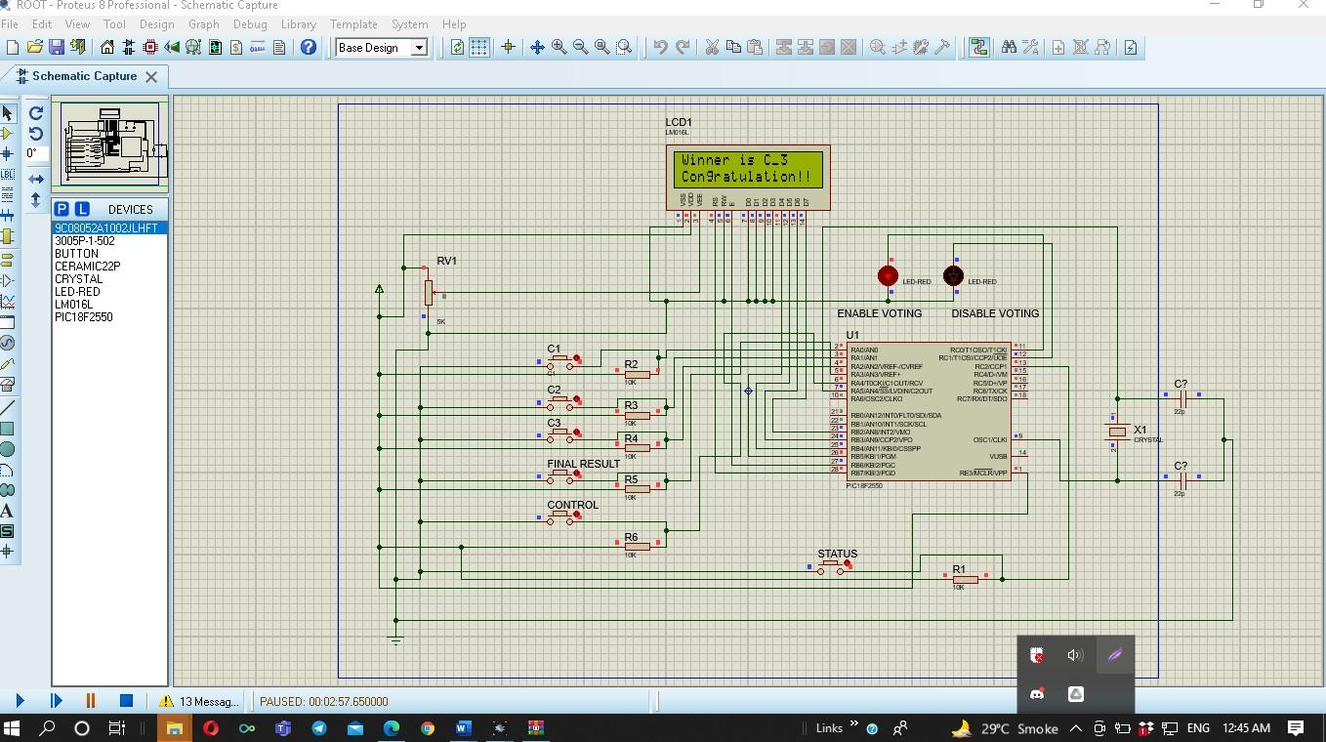

**ADVANTAGES AND DISADVANTAGES:**

**ADVANTAGES:-** The advantages of Digital Voting System are:

Election process becomes fast.

Accuracy and efficiency is high.

It has become popular for its Ease of use.

Process is confidential.

Online Voting reduces election costs.

**DISADVANTAGES:-** The disadvantages of Electronic Voting (e-voting) System are:

Once the vote is cast it cannot be modified. Hence the voter or the user has to be sure of his selection.

In case of voting through EVM’s the user has to go to the polling booth which might be inconvenient at times.

Internet voting or Remote voting might have issues regarding connectivity and delay associated with it.

Risks of i-voting include security and data integrity.

**CONCLUSION:**

**DVM- Digital Voting Machine.** Project is designed and implemented. The Project can be extended by adding a GSM/WIFI module which eases the operation of voting by sending a simple SMS over the network or access through a Web-page over the internet network.

**REFERENCE:-**

**➢ https://www.electronicshub.org**

**➢ https://en.m.wikipedia.org**

**➢ https://www.youtube.com**